**NATIONAL INSTITUTE OF TECHNOLOGY-TRICHY**



**ENERGY AND ENVIRONMENT PROJECT**

**IRRIGATION CONTROLLER**

**DONE BY:**

* ANANYA S
* ELENCHERAN MP
* R PAVITHRA
* S RAKSHANA
* RUPIKA S
* SRUTHI KURRA
* THANDU SIRIVALLI
* VARUN KARTHICK A

***TABLE OF CONTENTS***

|  |  |
| --- | --- |
| **S.No** | **TOPICS** |
| 1. | Acknowledgements |
| 2. | Abstract |
| 3. | Introduction |
| 4. | Motivation |
| 5. | Methodology |
| 6. | Working |
| 7. | Procedure |
| 8. | Code |
| 9. | Outcome |
| 10. | Scope for improvement |
| 11. | Conclusion |
| 12. | References |

***TEAM MEMBERS***

**1. Ananya S**

Department: Electronics and Communication Engineering

Section-A

Roll number: 108122013

**2. Elencheran MP**

Department: Electronics and Communication Engineering

Section-A

Roll number: 108122033

**3. R** **Pavithra**

Department: Electronics and Communication Engineering

Section-A

Roll number: 108122093

**4. S Rakshana**

Department: Electronics and Communication Engineering

Section-A

Roll number: 108122117

**5.** **Rupika S**

Department: Electronics and Communication Engineering

Section-A

Roll number: 108122095

**6.** **Sruthi Kurra**

Department: Electronics and Communication Engineering

Section-A

Roll number: 108122047

**7. Thandu Sirivalli**

Department: Electronics and Communication Engineering

Section-A

Roll number: 108122125

**8.** **Varun Karthick A**

Department: Electronics and Communication Engineering

Section-A

Roll number: 108122133

***ACKNOWLEDGEMENTS***

It has been a long and strenuous project, but we have finally reached the finish line with our final product. We owe an immense amount of gratitude to all those who contributed in one way or another; without you, this would not be possible. The completion of such a large-scale endeavour requires support from many people, so thank you for your contributions!

We would like to thank our professors for their support and guidance in completing our project- “Irrigation Controller”. We also extend our sincere gratitude to Mr Kannan- Department of Energy and Environment. It was a great learning experience.

We would also like to thank our senior Sanjeev Krishna for guiding us whenever we needed.

***ABSTRACT***

Our project’s idea has arisen due to the necessity for an efficient and timely system to water plants grown for domestic purposes.

We have worked towards developing a compact and user friendly “IoT based irrigation controller”. This prototype functions to water plants grown on a small scale.

In this project, we calibrate a capacitive soil moisture sensor that gauges the volumetric content of water present in the soil. This sensor is a part of a circuit which is integrated with an Arduino program, and controlled by the user via an app namely Blynk. The user gets to view the moisture level in the soil in a scale of 0-100.It is thus appropriately utilized to control a water pump connected to our circuit and the plants are supplied with water as and when required by the user.

This project aims to address multiple issues such as overwatering, underwatering, inefficient management of plant irrigation, and difficulty in monitoring plants remotely.

***INTRODUCTION***

Cultivating plants in a household is a small but important ecological initiative taken by many people. Apart from serving aesthetic purposes, plant cultivation is also an environment-friendly practice that has benefits such as improving air quality, removing harmful pollutants and many more.

However, one of the main concerns that we have identified is improper management of plant watering, uncontrolled wastage of water and difficulty to maintain plants remotely.

This project solves these issues in the following ways:

• During the hot summer months, proper attention to the plants’ water requirement and efficient irrigation management is critical. Manual watering of plants in these months is not only time and labour consuming, but also prone to human error. plant watering through buttons in mobiles saves time, human effort and efficiently waters the plant by monitoring the moisture content in the soil.

• An irrigation controller irrigates the plant only when necessary, and directs the water accurately to where it is required. This significantly reduces wastage of water which is caused due to over watering or inaccurate channelling of water to plants. This also improves overall soil quality as the problem of over watering is eliminated.

• It is also very useful to water plants from far away and helps the user attend to their plants remotely.

Hence this system monitors the plants, maintains soil quality, reduces wastage of water resources and hence benefits the environment. It also reduces the time and human effort involved in watering plants.

***MOTIVATION***

The motivation for this project came from our interest towards including the IoT in our project and we were keen to come up with something that reduces human involvement or atleast make it easy for him/her to perform a specific task.In lndia economy is based on agriculture and the climatic conditions and human exploitation lead to lack of rains & scarcity of water. Irrigation is moreover the backbone of Agricultural industry. Due to inadequate knowledge of proper utilization of water resource, lots of water is wastage in the application of irrigation system. So to overcome this problem , it is necessary to make the system partially or fully automate with the help of modern technology like “Internet of Things”.

Gardening at home on a small scale

requires manual intervention by cultivator to turn the pump ON/OFF whenever needed. In this project we tried to minimize this manual intervention by the cultivator. In recent times, the cultivators have been using irrigation technique through the manual control in which they water the plants at regular intervals by turning the water-pump ON/OFF when required. This process sometimes consumes more water and sometimes the water supply to the plants is delayed due to which the plants dry out. Therefore in this project we use an Android application -Blynk IoT which helps the cultivator to ON/OFF the motor without his physical presence .

***METHODOLOGY***

*Materials required/Components :*

◦ Nodemcu ESP8266(Microcontroller)

◦ Soil Moisture sensor

◦ Relay module

◦ Jumpers(Male to Male and Male to Female)

◦ Water pump

◦ Battery

◦ Breadboard

To program the microcontroller(ESP8266) Arduino IDE is used.

About the *Arduino IDE*

Arduino IDE is **an open-source software,** which is used to write and upload code to the Arduino UNO and many other Circuit boards including Nodemcu .It is based on C and C++(wiring) .It’s Basic structures include **void setup()** which is a mandatory function that runs once when the board is reset and **void loop()** which gets recalled repeatedly until the circuit board is turned off.

Using the above mentioned components we developed the circuit which uses IoT(Internet of things) as a result of which, the user can monitor and control the working of the irrigation controller through Blynk app.

In the Blynk app, user can see the readings of the soil moisture sensor being displayed on it. When the readings (moisture level) drops below the threshold value, user can turn ON/OFF the motor of the water pump.

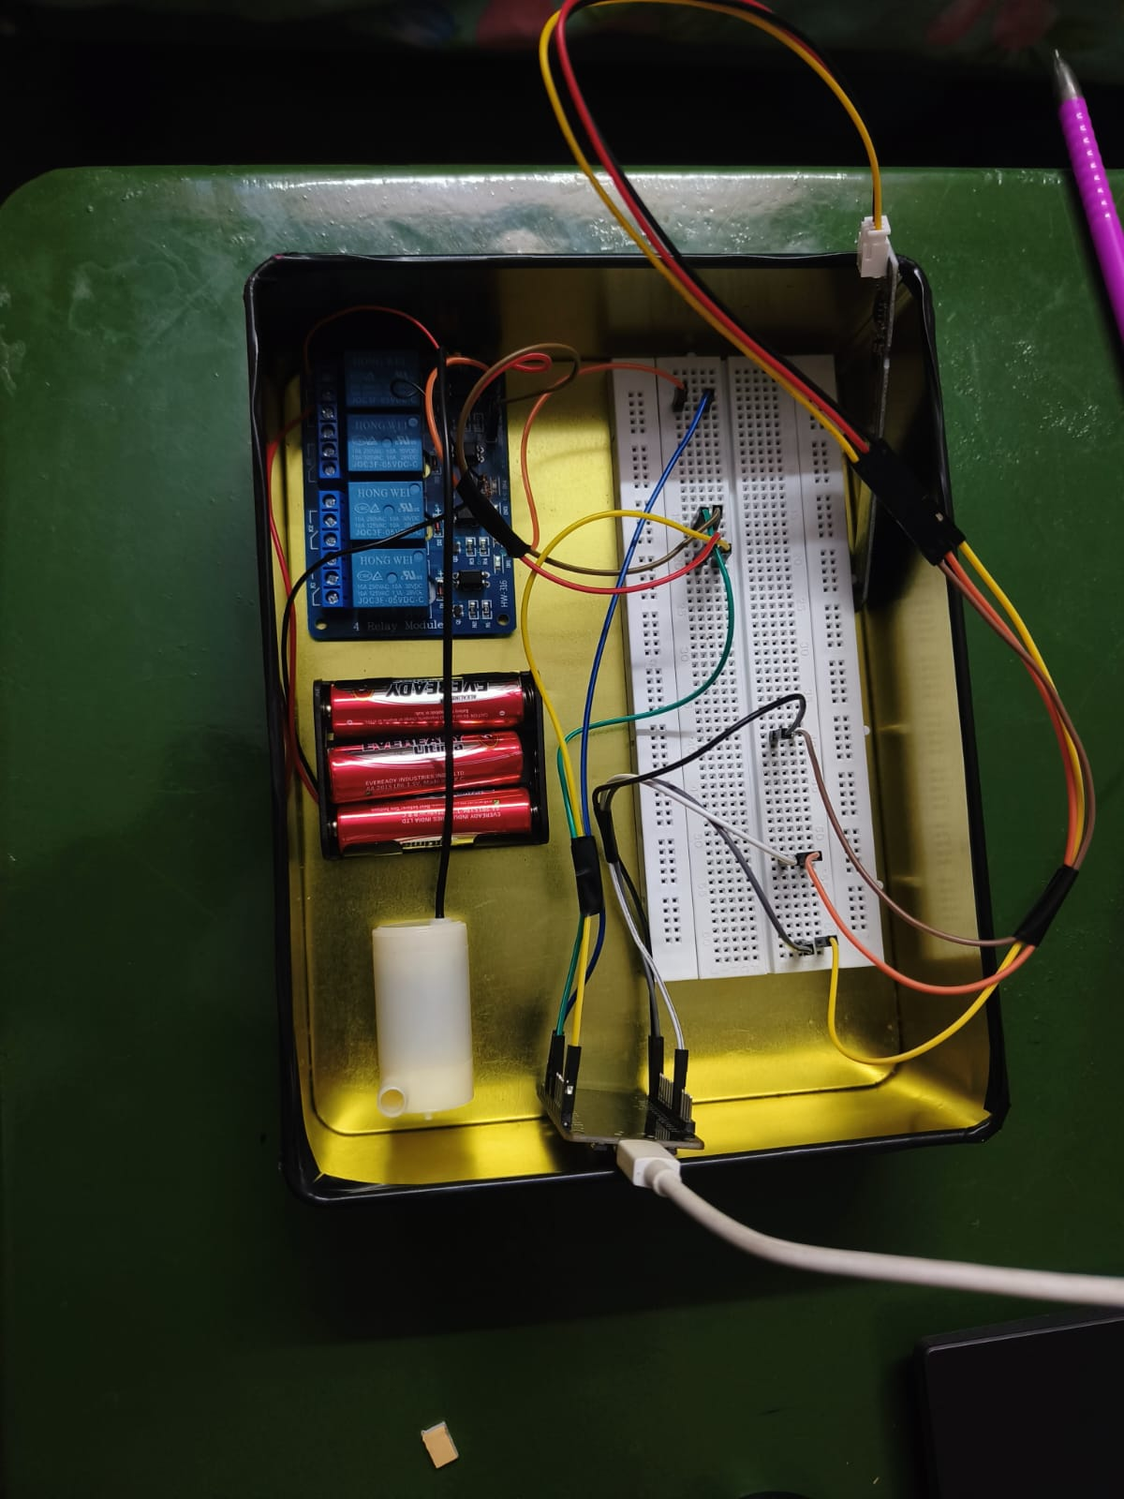

***WORKING***

The project deals with automated irrigation where NodeMCU ESP8266, relay module, Soil moisture sensor are the key components.

*Description of the key components:*

1. **NodeMCU ESP8266:**

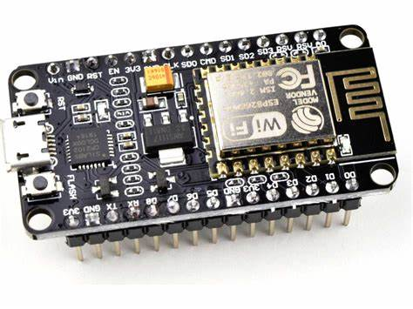

NodeMCU is an open source software and hardware development environment built around System-on-a-Chip(SoC), called ESP8266(Basically, the microcontroller of the board).This contains crucial elements of the computer like CPU, RAM, networking(Wi-Fi), and even a modern operating system.

Why did we prefer NodeMCU over Arduino UNO

The NodeMCU board consists of a Wi-Fi module(absent in a Arduino UNO board) which enables us to use the IoT technology.

Pinout Diagram of the NodeMCU and Description regarding the pins involved

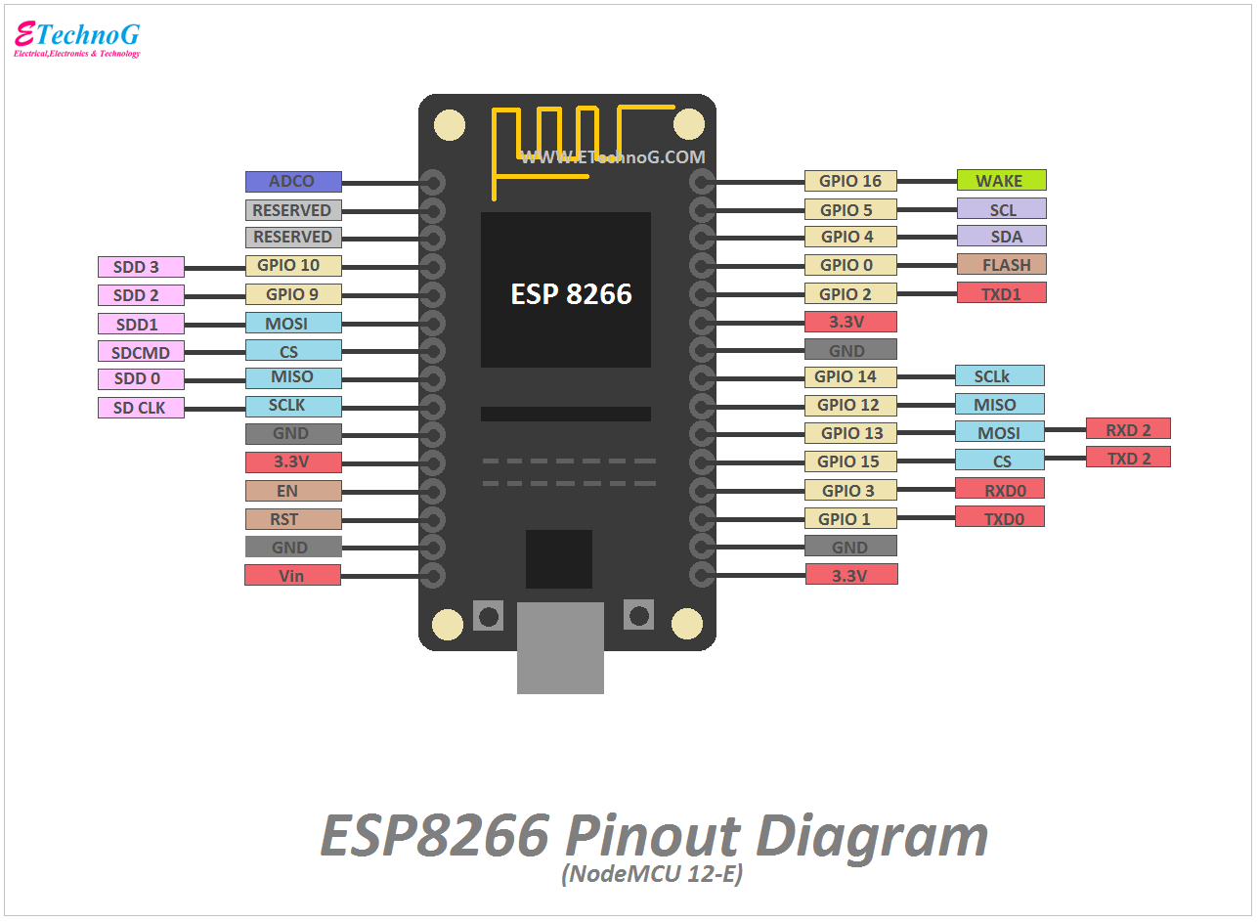

1. GND: To make a connection short to ground.
2. A0: Connected to any analog sensor to extract the voltage value ranging from [0-1024)
3. D3:Connected to any input or output device and uses only discrete values (0 and 1).
4. 3V3/3.3V/5V: To draw power of mentioned voltage.
5. **RELAY MODULE:**

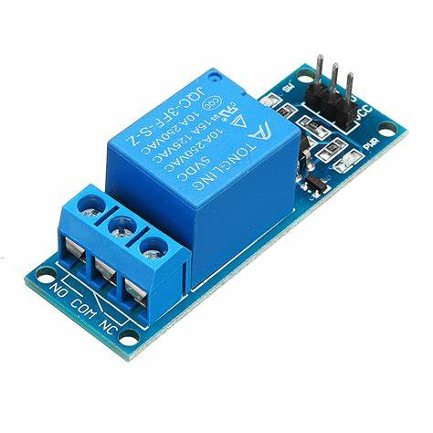

A power relay module is an electrical switch that is operated by an electromagnet. The electromagnet is activated by a separate low-power signal from a micro controller. When activated, the electromagnet pulls to either open or close an electrical circuit.

1. **SOIL MOISTURE SENSOR:**

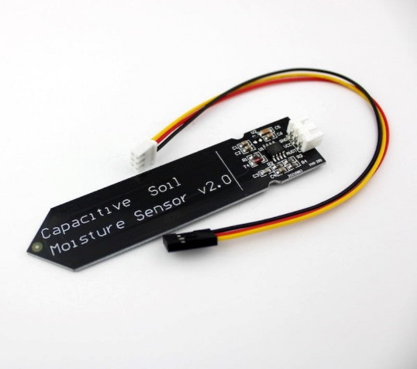

The soil moisture sensor is one kind of sensor used to gauge the volumetric content of water within the soil.

***PROCEDURE***

1. Connect the microcontroller with soil moisture sensor via A0 (analog) pin so as to get input from it as it measures the moisture content in the soil.
2. Connect microcontroller with a relay module via D3 (digital) pin to IN1(input pin). Connect their ground pins (GND) together and finally connect 3V3 pin of microcontroller to VCC pin of relay module.
3. Make connections between relay module and the motor pump and battery through normally close, normally open and common contact of the relay module.
4. Through USB connector, make connection between microcontroller and the system to program the microcontroller by coding in Arduino IDE.
5. We are using IoT(Internet of things) and as a result the entire setup is controlled by the user via Blynk app.

Creating the Blynk Interface:

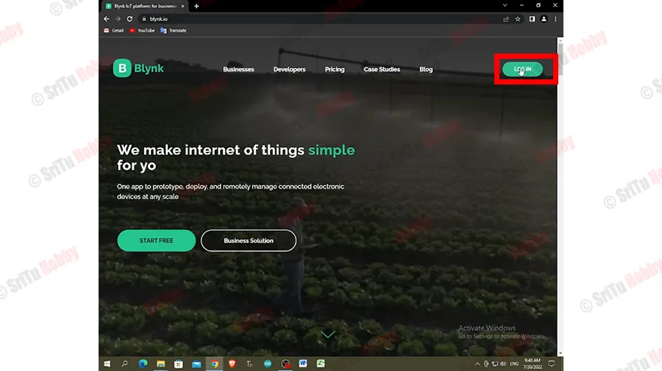 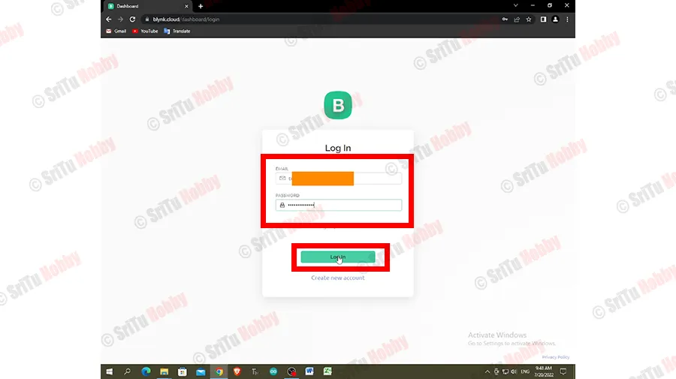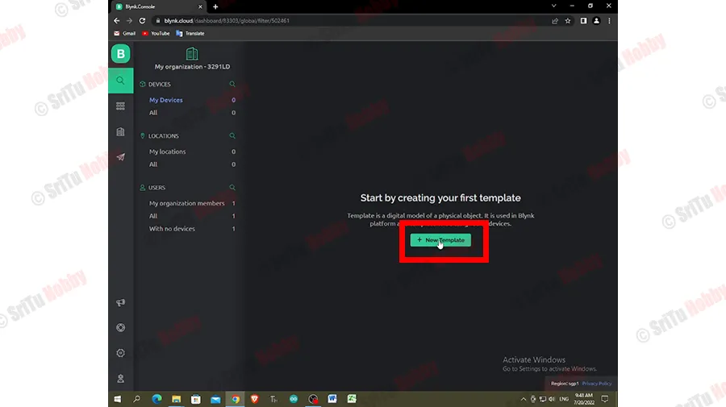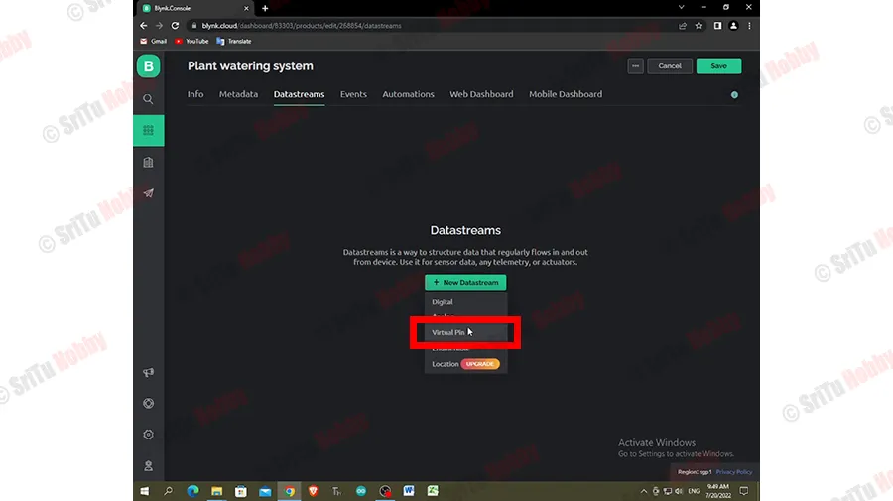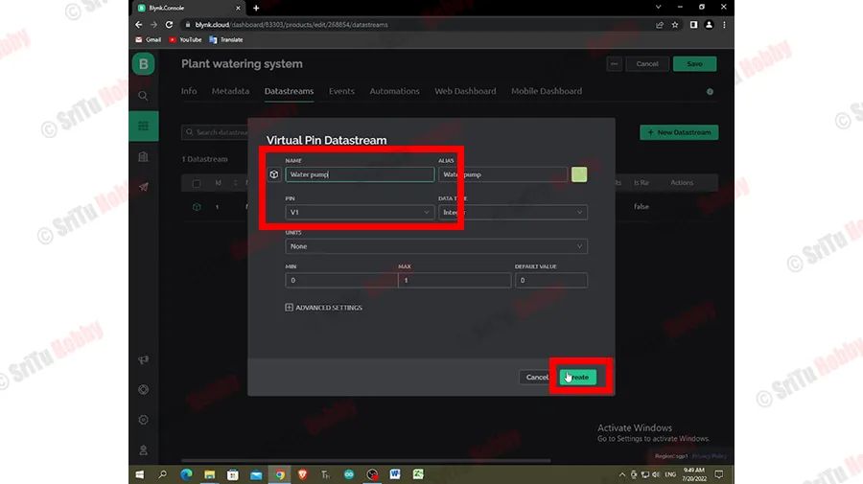

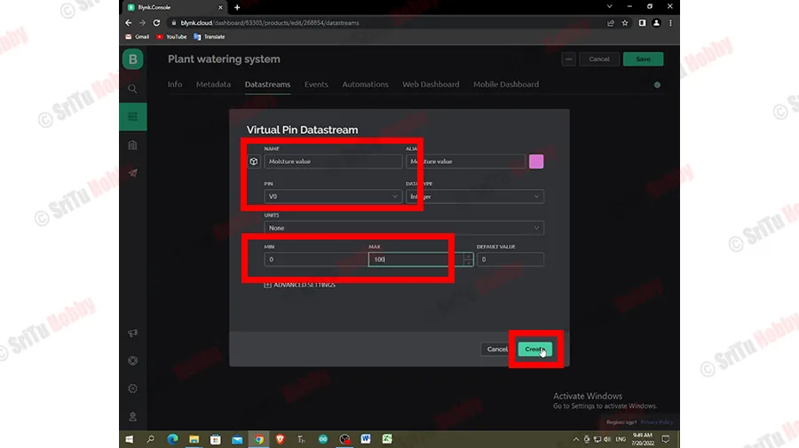

***CODE***

//Include the library files

#define BLYNK_PRINT Serial

#include <ESP8266WiFi.h>

#include <BlynkSimpleEsp8266.h>

char auth[] = "m6HmEOW8RxT3arlghVhnNdk6b0vrM323";

***//Enter your Auth token***

char ssid[] = "iQOO Neo6";

***//Enter your WIFI name***

char pass[] = "gowthambala";

***//Enter your WIFI password***

BlynkTimer timer;

bool Relay = 0;

***//Define component pins***

#define sensor A0

#define waterPump D3

void setup() {

Serial.begin(9600);

pinMode(waterPump, OUTPUT);

digitalWrite(waterPump, HIGH);

Blynk.begin(auth, ssid, pass, "blynk.cloud", 80);

***//Call the function***

timer.setInterval(100L, soilMoistureSensor);

}

***//Get the button value***

BLYNK_WRITE(V1) {

Relay = param.asInt();

if (Relay == 1) {

digitalWrite(waterPump, LOW);

} else {

digitalWrite(waterPump, HIGH);

}

}

***//Get the soil moisture values***

void soilMoistureSensor() {

int value = analogRead(sensor);

value = map(value, 0, 1024, 0, 100);

value = (value - 100) * -1;

Serial.println(value);

Blynk.virtualWrite(V0, value);

}

void loop() {

Blynk.run();

***//Run the Blynk library***

timer.run();

***//Run the Blynk timer***

}

***OUTCOME***

With the help of all the required components, we made connections and built the final circuit. Water is let to flow from the source to the plant. Here, the flow of water is controlled with the help of Blynk app by the codes that we included in the project. The components that play major role are NodeMCU and soil moisture sensor. In this project we have used the technology -IoT.IoT is nowadays used in the devices that are operated by signal from the devices like wireless connections. Once the circuit is ready with the code included in the product, the required output is achieved.Now, he/she can monitor her garden from the bed and water them with ease.

***SCOPE FOR IMPROVEMENT***

1. *Setting up mobile notifications:*

The Blynk modules and libraries could be explored more and the setup can be upgraded in such a way that whenever the pump is switched ON, the user gets a floating notification which would ensure that the user would not forget to turn OFF the pump.

1. *3D-Modelling:*

This prototype can be made into a compact product for indoor plants. The 3D modelling also ensures security for the circuit connections and adds convenience for the user.

1. *Replacement DC battery by Renewable energy:*

Instead of using the battery, usage of the Solar energy could also contribute towards Power saving.

1. *Upgradation on the Wi-Fi module:*

Besides being very useful, the Wi-Fi module also throws a restriction of user’s location. The user must be present in the vicinity of the common Wi-Fi to control the system from the mobile phone. Usage of circuit boards that could be connected to the satellite would nullify the restriction and there would be no need to have the laptop alongside.

1. *Multiple Analog Pins:*

Circuit boards with multiple analog pins along with Wi-Fi module would have the advantage of operating two or more pumps with a single microcontroller.

***CONCLUSION***

We have been working on this project with the help of various references and ideas from seniors. This irrigation controller helps in small scale irrigation at your homes itself. Finally be it small or big any effort towards efficient water usage is a potential contributor for the betterment of the society.

***REFERENCES***

<https://youtu.be/ASLpRciJBwk>

<https://youtu.be/ii7PCV2zvms>

<https://youtu.be/KSfqm2E3v70>

<https://www.google.com/search?q=how+to+connect+soil+moisture+sensor+with+arduino&rlz=1CDGOYI_enIN1025IN1025&oq=how+to+connect+soil+moisture+sensor&aqs=chrome.0.0i512j69i57j0i512l3j0i22i30.7601j0j4&hl=en-GB&sourceid=chrome-mobile&ie=UTF-8>